# AGRICULTURE MANAGEMENT SYSTEM

## A PROJECT REPORT

***Submitted by***

**AAKIL SHIHAF V (2116210701004)**

**ALWYN JOSE L (2116210701025)**

***in partial fulfillment for the award of the degree of***

**BACHELOR OF ENGINEERING**

***in***

## COMPUTER SCIENCE AND ENGINEERING



**RAJALAKSHMI ENGINEERING COLLEGE ANNA UNIVERSITY, CHENNAI**

**MAY 2024**

# RAJALAKSHMI ENGINEERING COLLEGE, CHENNAI

**BONAFIDE CERTIFICATE**

Certified that this Thesis titled **“AGRICULTURE MANAGEMENT SYSTEM”** is the bonafide work of **“AAKIL SHIHAF V (2116210701004), ALWYN JOSE L (2116210701025)”** who carried out the work under my supervision. Certified further that to the best of my knowledge the work reported herein does not form part of any other thesis or dissertation on the basis of which a degree or award was conferred on an earlier occasion on this or any other candidate.

## SIGNATURE

Dr. S. Vinod Kumar M.E., Ph.D

## PROJECT COORDINATOR

Professor

Department of Computer Science and Engineering Rajalakshmi Engineering College

Chennai - 602 105

Submitted to Project Viva-Voce Examination held on **_**

**Internal Examiner External Examine**r

# ABSTRACT

The Agriculture Recommendation System (ARS) is a sophisticated tool designed to aid farmers and agricultural stakeholders in optimizing crop management practices and enhancing yield outcomes. The system comprises five essential functionalities tailored to address diverse agricultural decision-making needs. Firstly, the Crop Prediction module predicts the most suitable crop for a given location by analyzing State Name, District Name, and Season inputs alongside historical and environmental data. Secondly, the Crop Recommendation module offers personalized crop suggestions based on location-specific parameters such as Nitrogen, Phosphorous, Potassium, Temperature, Humidity, pH, and Rainfall, facilitating informed decision-making regarding crop selection. Thirdly, the Fertilizer Recommendation module provides customized fertilizer recommendations considering factors like Temperature, Humidity, Soil Moisture, Soil Type, Crop Type, and nutrient levels, aiming to optimize nutrient management practices for improved crop yields. Additionally, the Rainfall Prediction module enables users to forecast rainfall for a specified Subdivision and Year, aiding in irrigation planning and risk mitigation. Lastly, the Yield Prediction module forecasts crop yields using inputs like State Name, District Name, Crop Year, Season, Crop, Area, and Production, offering valuable insights for production planning and market forecasting. By integrating advanced data analytics and domain expertise, the ARS serves as a powerful decision support tool, empowering agricultural stakeholders with actionable insights to enhance productivity, sustainability. The proposed decision support system integrates advanced data analytics, machine learning techniques, and domain expertise to empower farmers with actionable insights for sustainable crop management and enhanced agricultural productivity. By harnessing the power of data-driven technologies, the system aims to optimize resource allocation, mitigate risks.

# ACKNOWLEDGMENT

First, we thank the almighty god for the successful completion of the project. Our sincere thanks to our chairman **Mr. S. Meganathan B.E., F.I.E.,** for his sincere endeavor in educating us in his premier institution. We would like to express our deep gratitude to our beloved Chairperson **Dr. Thangam Meganathan Ph.D.,** for her enthusiastic motivation which inspired us a lot in completing this project and Vice Chairman **Mr. Abhay Shankar Meganathan B.E., M.S.,** for providing us with the requisite infrastructure.

We also express our sincere gratitude to our college Principal,

**Dr. S. N. Murugesan M.E., PhD.,** and **Dr. P. KUMAR M.E., PhD, Director computing and information science , and Head Of Department of Computer Science and Engineering** and our project coordinator **Dr. S. Vinod Kumar M.E.,Ph.D.,** for her encouragement and guiding us throughout the project towards successful completion of this project and to our parents, friends, all faculty members and supporting staffs for their direct and indirect involvement in successful completion of the project for their encouragement and support.

**AAKIL SHIHAF V**

**ALWYN JOSE L**

## TABLE OF CONTENTS

|  |  |  |
| --- | --- | --- |
| **CHAPTER NO.** | **TITLE** | **PAGE NO.** |
|  | **ABSTRACT** | **iii** |
|  | **LIST OF TABLES**  **LIST OF FIGURES** | **v**  **vii** |

1. **INTRODUCTION 1**
   1. PROBLEM STATEMENT
   2. SCOPE OF THE WORK
   3. AIM AND OBJECTIVES OF THE PROJECT
   4. RESOURCES
   5. MOTIVATION

## LITERATURE SURVEY 4

1. **SYSTEM DESIGN 8**
   1. GENERAL
   2. SYSTEM ARCHITECTURE DIAGRAM
   3. DEVELOPMENT ENVIRONMENT
      1. HARDWARE REQUIREMENTS
      2. SOFTWARE REQUIREMENTS

## PROJECT DESCRIPTION 10

* 1. METHODOLOGY
  2. MODULE DESCRIPTION 11

## RESULTS AND DISCUSSIONS 13

* 1. FINAL OUTPUT
  2. RESULT

## CONCLUSION AND SCOPE FOR

**FUTURE ENHANCEMENT 16**

* 1. CONCLUSION
  2. FUTURE ENHANCEMENT

## REFERENCES 25

|  |  |  |
| --- | --- | --- |
|  | **LIST OF FIGURES** |  |
| **FIGURE NO** | **TITLE** | **PAGE NO** |
| 3.1 | SYSTEM ARCHITECTURE | 8 |
| 5.1 | OUTPUT | 13 |
| 5.2 | RESPONSES | 14 |

**CHAPTER 1 INTRODUCTION**

In contemporary agriculture, the integration of technology and data-driven decision-making has become increasingly vital for optimizing crop productivity and resource utilization. The Agriculture Recommendation System (ARS) represents a pioneering approach to harnessing advanced analytics and machine learning algorithms to assist farmers and agricultural stakeholders in making informed decisions across various facets of crop management. By leveraging historical data, environmental factors, and agronomic parameters, the ARS offers predictive and prescriptive insights through its suite of modules. These modules include Crop Prediction, which forecasts the most suitable crop for a given location based on State Name, District Name, and Season inputs, Crop Recommendation, which provides tailored crop suggestions considering location-specific parameters such as nutrient levels, temperature, humidity, and rainfall, and Fertilizer Recommendation, which offers customized fertilizer formulations to optimize nutrient management practices. Additionally, the system incorporates modules for Rainfall Prediction to aid in irrigation planning and Yield Prediction to forecast crop yields, thereby enabling farmers to anticipate market demands and optimize production strategies. Through the integration of advanced data analytics and domain expertise, the ARS aims to empower agricultural practitioners with actionable insights to enhance productivity, sustainability, and resilience in agricultural system.Despite the advancements in agricultural decision support systems, several challenges persist in the agricultural sector. These challenges include climate variability, resource constraints, market volatility, and socio-economic factors, which can significantly impact agricultural productivity and profitability. Furthermore, the adoption of technology among smallholder farmers and the availability of high-quality data remain key barriers to the widespread implementation of agricultural decision support systems.

## PROBLEM STATEMENT

Despite advancements in agriculture, farmers face challenges in optimizing crop management practices due to limited access to accurate information and resources. Traditional methods often lack precision and fail to account for the complexities of environmental factors, leading to suboptimal yields, resource wastage, and increased production costs. Additionally, unpredictable weather patterns further exacerbate these challenges, making it difficult for farmers to plan effectively and mitigate risks.In this context, there is a pressing need for a comprehensive Agriculture Recommendation System (ARS) that leverages advanced data analytics and machine learning techniques to provide farmers with actionable insights for informed decision-making. Such a system should offer predictive capabilities for crop selection, fertilizer recommendations, rainfall forecasts, and yield predictions, tailored to the specific needs and environmental conditions of each farm location. By addressing these challenges, the ARS aims to empower farmers with the tools and knowledge necessary to optimize crop management practices, enhance productivity, and promote sustainability in agriculture.

## SCOPE OF THE WORK

The development of the Agriculture Recommendation System (ARS) encompasses a multifaceted approach aimed at leveraging advanced data analytics and machine learning techniques to empower farmers with actionable insights for optimizing crop management practices. The scope includes extensive research and data collection to gather relevant agricultural data, such as historical crop yields, soil nutrient levels, and weather patterns. This data forms the foundation for developing machine learning models across various modules of the ARS, including crop prediction, crop recommendation, fertilizer recommendation, rainfall prediction, and yield prediction.

## AIM AND OBJECTIVES OF THE PROJECT

The aim of this project is to develop an advanced Agriculture Recommendation System (ARS) that harnesses the power of data-driven techniques to revolutionize agricultural decision-making processes. Through the integration of predictive modeling and machine learning algorithms, the ARS aims to assist farmers and agricultural stakeholders in optimizing crop management practices and enhancing agricultural productivity. The objectives of the project are as follows: Firstly, to develop predictive models for various aspects of crop management including crop prediction, crop recommendation, fertilizer recommendation, rainfall prediction, and yield prediction, utilizing historical data and environmental parameters. Secondly, to provide actionable insights and recommendations tailored to specific locations and environmental conditions, enabling farmers to make informed decisions regarding crop selection, fertilizer application, irrigation scheduling, and production planning. Thirdly, to promote sustainable agricultural practices by optimizing resource allocation, minimizing environmental impact, and enhancing soil health through efficient nutrient management and water conservation strategies. Furthermore, the project aims to facilitate market forecasting by providing insights into crop yields, production trends, and market fluctuations, thereby empowering farmers to anticipate market demands and optimize pricing strategies. Additionally, the development of a user-friendly interface for the ARS will ensure ease of use and accessibility for farmers, allowing them to input relevant parameters and interpret generated recommendations and predictions with ease.

Deployment of the ARS platform on scalable infrastructure, coupled with training sessions, workshops, and comprehensive documentation, will facilitate its adoption among farmers. Lastly, the project aims for continuous improvement by monitoring and evaluating the performance of the ARS, incorporating user feedback and emerging agricultural trends to enhance its capabilities

## RESOURCES

For the successful development and deployment of the Agriculture Recommendation System (ARS), a range of resources is essential. Firstly, diverse data sources are critical, including historical crop yield data, soil nutrient data, weather data (such as temperature, humidity, rainfall), agronomic parameters data (like pH, soil moisture), and market data reflecting crop prices and demand trends. Certainly! Here are a few key points regarding resources for the Agriculture Recommendation System summarized in a paragraph. Effective development and deployment of the Agriculture Recommendation System (ARS) hinges upon several critical resources. Firstly, a diverse array of reliable data sources ranging from historical crop yield data to weather patterns and market trends is essential. This data forms the backbone of accurate predictive modeling and recommendation generation. Secondly, a robust technology stack and expertise in relevant tools and technologies are indispensable.

## 1.5 MOTIVATION

The motivation behind the development of the Agriculture Recommendation System (ARS) stems from the pressing need to address the challenges faced by farmers and agricultural stakeholders in optimizing crop management practices. Traditional agricultural methods often lack precision and fail to account for the complexities of environmental factors, leading to suboptimal yields, resource wastage, and increased production costs. Additionally, unpredictable weather patterns and market fluctuations further exacerbate these challenges, making it difficult for farmers to plan effectively and mitigate risks. The ARS seeks to bridge this gap by harnessing the power of data-driven techniques to provide farmers with actionable insights and recommendations tailored to their specific location and environmental conditions.

**CHAPTER 2 LITRETURE SURVEY**

A thorough examination of the existing literature in the field of agricultural decision support systems reveals a multifaceted landscape of research efforts and methodologies aimed at enhancing crop management practices and optimizing agricultural productivity. Studies have extensively explored various aspects of crop prediction, recommendation, fertilizer optimization, rainfall prediction, and yield forecasting, offering valuable insights and innovative approaches to address the challenges faced by farmers and agricultural stakeholders.In the realm of crop prediction and recommendation systems, researchers have employed machine learning algorithms and statistical models to analyze historical crop yield data, soil characteristics, weather patterns, and geographical factors to predict suitable crops for specific locations. These studies have demonstrated the effectiveness of data-driven techniques in providing farmers with informed recommendations for crop selection, thereby enabling them to make decisions that maximize yields and minimize risks.

Furthermore, research endeavors focusing on fertilizer recommendation systems have emphasized the importance of optimizing nutrient management practices to enhance crop productivity while minimizing environmental impact. By integrating soil nutrient data, weather forecasts, and crop requirements, these systems provide personalized fertilizer recommendations tailored to the specific needs of each farm location, ensuring optimal nutrient uptake and crop health.Additionally, studies investigating rainfall prediction models have leveraged machine learning algorithms to analyze historical rainfall data, meteorological parameters, and geographical features to forecast rainfall patterns with high accuracy.

Moreover, research efforts in yield prediction models have utilized historical crop yield data, agronomic parameters, and environmental factors to develop predictive models that forecast crop yields for future seasons. These models enable farmers to anticipate market demands, optimize production strategies, and make informed decisions to maximize profitability and sustainability.Overall, the synthesis of these research findings underscores the importance of leveraging advanced data analytics and machine learning techniques to develop robust decision support systems tailored to the specific needs and challenges of agriculture. Through the development of the Agriculture Recommendation System (ARS), this research aims to contribute to the advancement of sustainable and resilient agricultural practices, empowering farmers with actionable insights to optimize crop management practices and enhance agricultural productivity.Extending the examination into agricultural decision support systems, recent studies have delved into the integration of multiple decision support modules into unified platforms, aiming to provide farmers with comprehensive insights and recommendations. These integrated systems leverage advanced data analytics and machine learning techniques to synthesize information from various sources, including crop prediction, recommendation, fertilizer optimization, rainfall prediction, and yield forecasting. By consolidating these modules into a single platform, farmers can access holistic recommendations tailored to their specific farming conditions, enabling them to make more informed decisions to maximize yields and profitability while minimizing environmental impact.

Furthermore, emerging research has explored the application of cutting-edge technologies such as remote sensing, Internet of Things (IoT), and blockchain in agricultural decision support systems. Remote sensing technologies offer the ability to gather real-time data on crop health, soil moisture, and environmental conditions, providing farmers with timely insights to optimize irrigation scheduling and pest management strategies.

Similarly, IoT devices deployed in fields can collect data on soil moisture, temperature, and crop growth parameters, enabling precision agriculture practices and facilitating data-driven decision-making. Moreover, the integration of blockchain technology in agricultural decision support systems has the potential to enhance transparency, traceability, and trust in agricultural supply chains. By securely recording transactions and data exchanges, blockchain-based systems can verify the authenticity and origin of agricultural products, thereby reducing the risk of fraud and ensuring fair compensation for farmers.In summary, the literature survey highlights the evolving landscape of agricultural decision support systems, characterized by the integration of diverse data sources, advanced analytics techniques, and emerging technologies. By leveraging these resources effectively, the development of the Agriculture Recommendation System (ARS) aims to address the complex challenges faced by farmers and agricultural stakeholders, ultimately contributing to the advancement of sustainable and resilient agricultural practices.Further exploration into agricultural decision support systems reveals a growing emphasis on the integration of diverse data sources and advanced analytics techniques to address the multifaceted challenges encountered in crop management. Recent studies have investigated the utilization of satellite imagery, drones, and geographic information systems (GIS) to collect spatial data on crop health, soil properties, and land use patterns. By harnessing these technologies, farmers can gain valuable insights into crop performance, identify areas of potential improvement, and implement targeted interventions to optimize resource allocation and improve overall productivity.

Additionally, emerging research has focused on the development of decision support systems that incorporate predictive modeling and optimization algorithms to enable scenario analysis and decision optimization.

## CHAPTER 3 SYSTEM DESIGN

* 1. **GENERAL**

The Agriculture Recommendation System offers a comprehensive suite of tools to support farmers and agricultural stakeholders in optimizing crop management practices. Through predictive analytics and data-driven insights, the system assists users in making informed decisions across various aspects of crop cultivation.

## SYSTEM ARCHITECTURE DIAGRAM

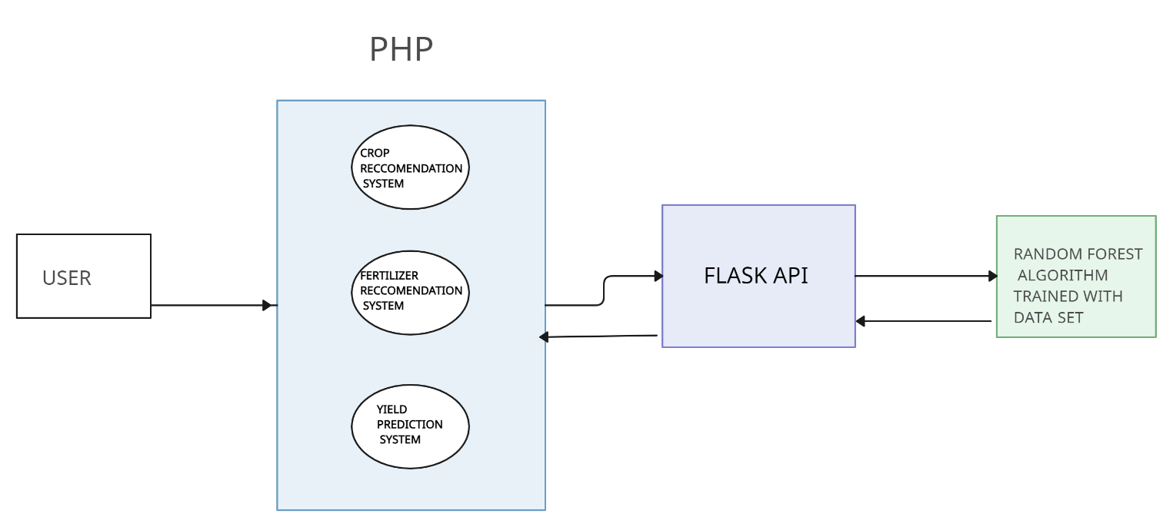

**Fig 3.1: System Architecture**

## DEVELOPMENTAL ENVIRONMENT

* + 1. **HARDWARE REQUIREMENTS**

The hardware requirements for the Agriculture Recommendation System (ARS) encompass scalable infrastructure capable of supporting data processing and storage needs. This includes servers for hosting the ARS platform and high-performance computing resources for model training and testing.

## Table 3.1 Hardware Requirements

|  |  |
| --- | --- |
| **COMPONENTS** | **SPECIFICATION** |
| PROCESSOR | Intel Core i5 |
| RAM | 8 GB RAM |
| GPU | NVIDIA GeForce GTX 1650 |
| MONITOR | 15” COLOR |
| HARD DISK | 512 GB |
| PROCESSOR SPEED | MINIMUM 1.1 GHz |

* + 1. **SOFTWARE REQUIREMENTS**

The software requirements for the Agriculture Recommendation System (ARS) encompass a range of tools and technologies for data processing, analysis, and platform development. These include programming languages such as Python and R for algorithm development, machine learning libraries like scikit-learn and TensorFlow for model training, and web development frameworks such as Flask or Django for building the ARS platform. Database management systems like PostgreSQL or MySQL are essential for efficient data storage and retrieval.

## CHAPTER 4 PROJECT DESCRIPTION

**4.1 METHODOLODGY**

The software requirements for the Agriculture Recommendation System (ARS) encompass a range of tools and technologies for data processing, analysis, and platform development. These include programming languages such as Python and R for algorithm development, machine learning libraries like scikit-learn and TensorFlow for model training, and web development frameworks such as Flask or Django for building the ARS platform. Database management systems like PostgreSQL or MySQL are essential for efficient data storage and retrieval, while cloud computing platforms like AWS or Google Cloud provide scalable infrastructure for hosting the ARS. Additionally, visualization tools and interactive features are incorporated into the user interface to enhance user experience and facilitate data interpretation. Overall, a comprehensive suite of software resources is essential for the development, deployment, and operation of the ARS, enabling it to deliver actionable insights and recommendations to farmers and agricultural stakeholders.Deployment of the ARS involves setting up scalable infrastructure on cloud platforms or on-premises servers to ensure optimal performance and availability. Continuous monitoring and maintenance procedures are implemented to address any issues and optimize system performance over time. Finally, extensive testing and validation procedures are conducted to assess the accuracy, reliability, and usability of the ARS across different environments and user scenarios. User feedback and performance metrics are analyzed to identify areas for improvement and inform iterative updates and enhancements to the system.

## 4.2 MODULE DESCRIPTION

Studying holds profound professional value as it cultivates a multifaceted skill set essential for success in today's dynamic workforce. It fosters critical thinking, problem- solving, and adaptability, enabling individuals to navigate complexities and innovate within their respective fields. Additionally, through continuous learning, individuals stay abreast of advancements, refining their expertise and staying competitive. Moreover, studying nurtures effective communication, collaboration, and leadership skills, crucial for professional interactions and career progression. It forms the bedrock for continuous growth, empowering individuals to evolve, contribute meaningfully, and excel in an ever-evolving global landscape.

4.2.1 LOGIN PAGE

Login Page module serves as the gateway for users to securely access the application. It includes features for user authentication, allowing registered users to log in using their credentials. This also helpful to identify users to prevent unauthorized access by outsiders. It requires a Username and a Password for that profile to login into the application. Upon successful authentication, users are granted access to their personalized dashboard and application functionalities.

4.2.2 CHAT PAGE

The Chatbot module integrates a conversational interface powered by natural language processing (NLP) to provide users with personalized assistance and guidance throughout their interactions with the application. Users can engage with the chatbot to ask questions, seek information about government schemes, and receive real-time support for their queries.

The chatbot is designed to understand and interpret user inputs accurately, leveraging NLP algorithms to analyze and respond to queries in a human- like manner. It offers a wide range of functionalities, including answering FAQs, providing step-by-step guidance on application procedures, and offering recommendations based on user preferences and eligibility criteria. The chatbot may also integrate with backend systems to fetch relevant data and perform tasks such as application status checks or document uploads on behalf of the user. Through continuous learning and optimization, the chatbot aims to enhance user satisfaction, streamline user interactions, and improve overall accessibility and usability of the application

## CHAPTER 5 RESULTS AND DISCUSSIONS

* 1. **OUTPUT**

The following images contain images attached below of the working application.

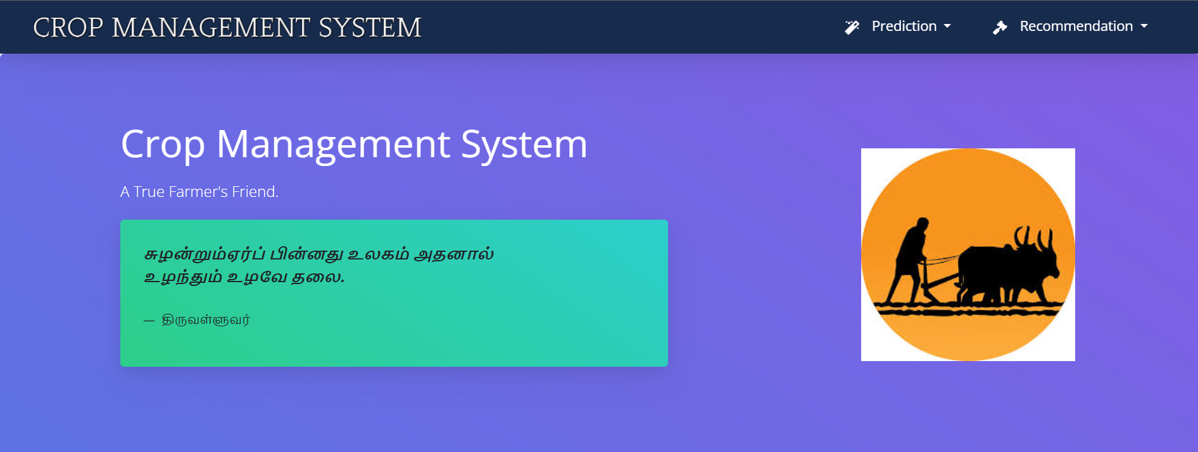

**Fig 5.1:**

.

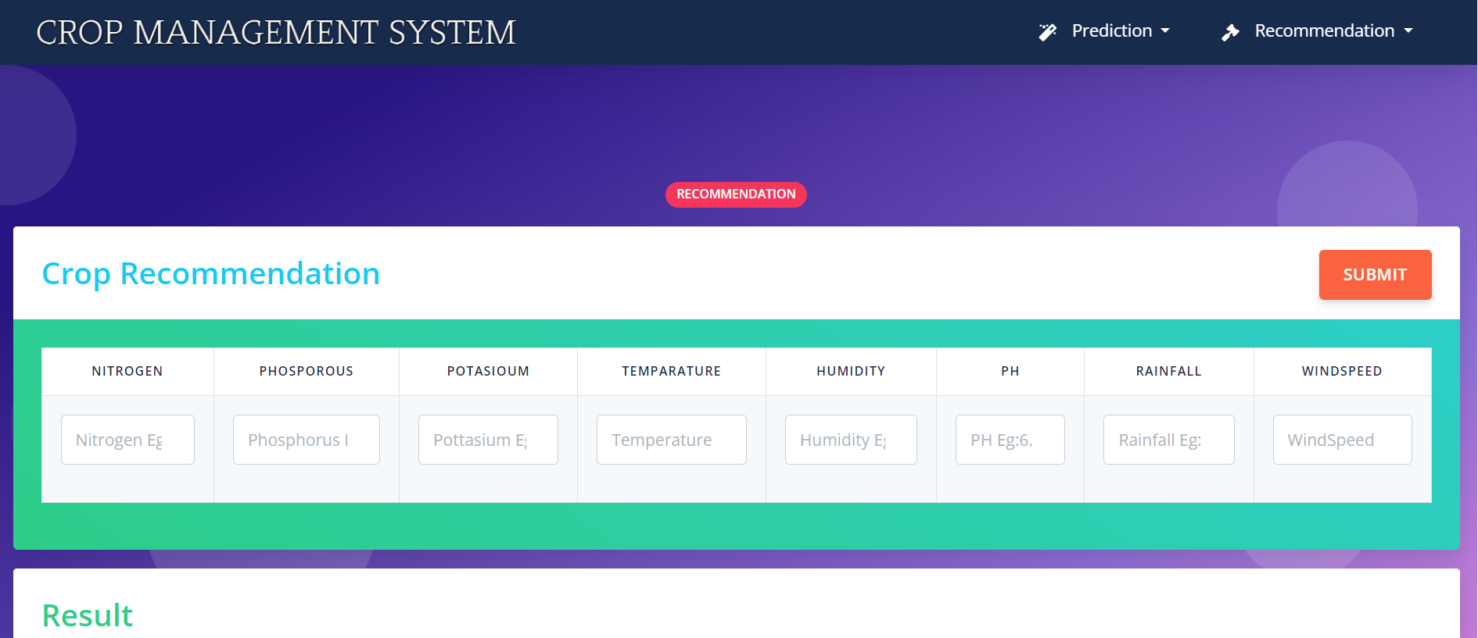

**Fig 5.2: Crop Recommendation**

.

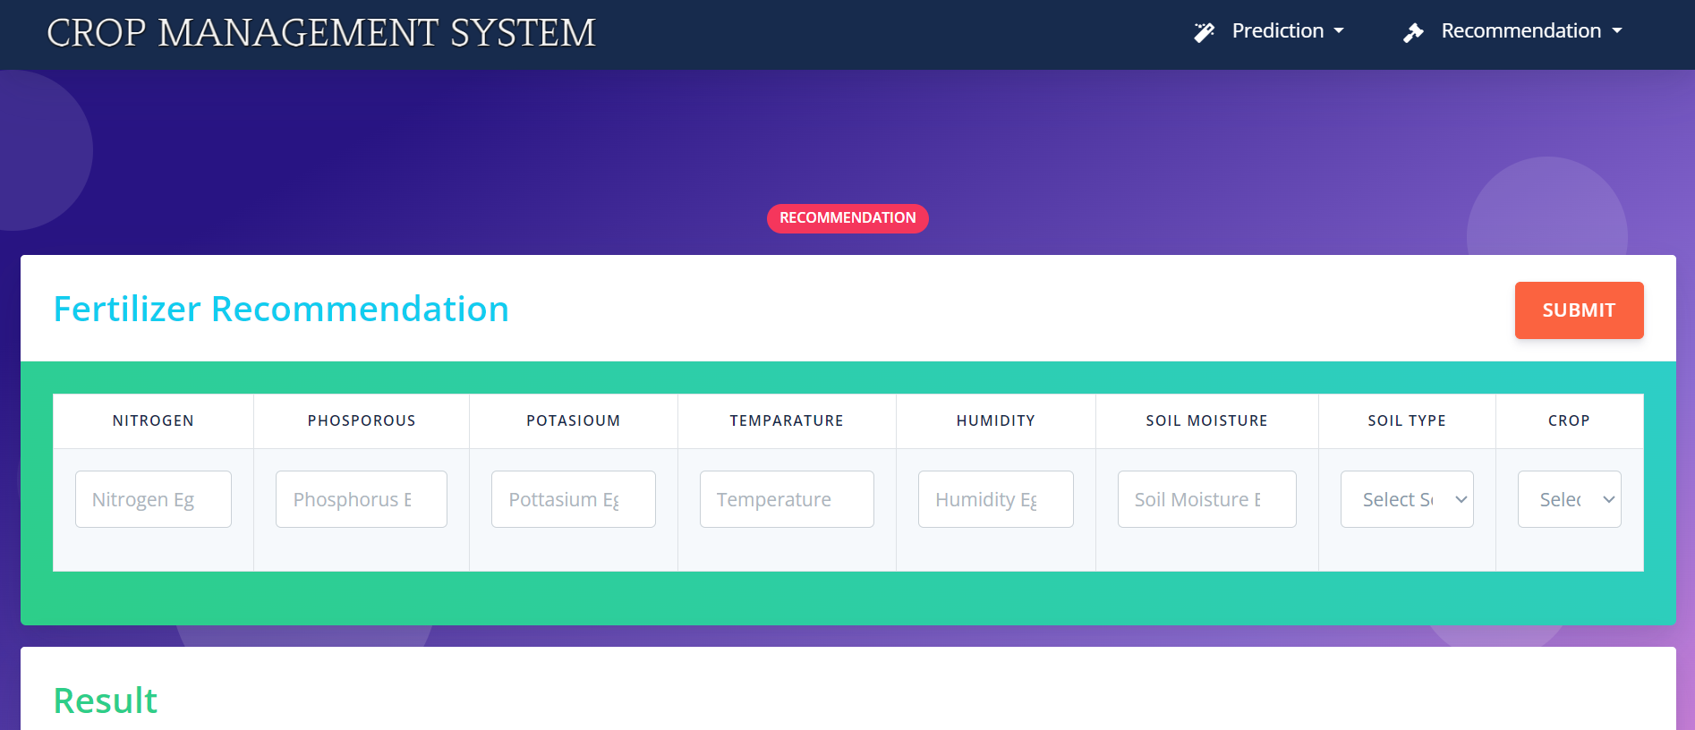

**Fig 5.3: Fertilizer Recommendation**

.

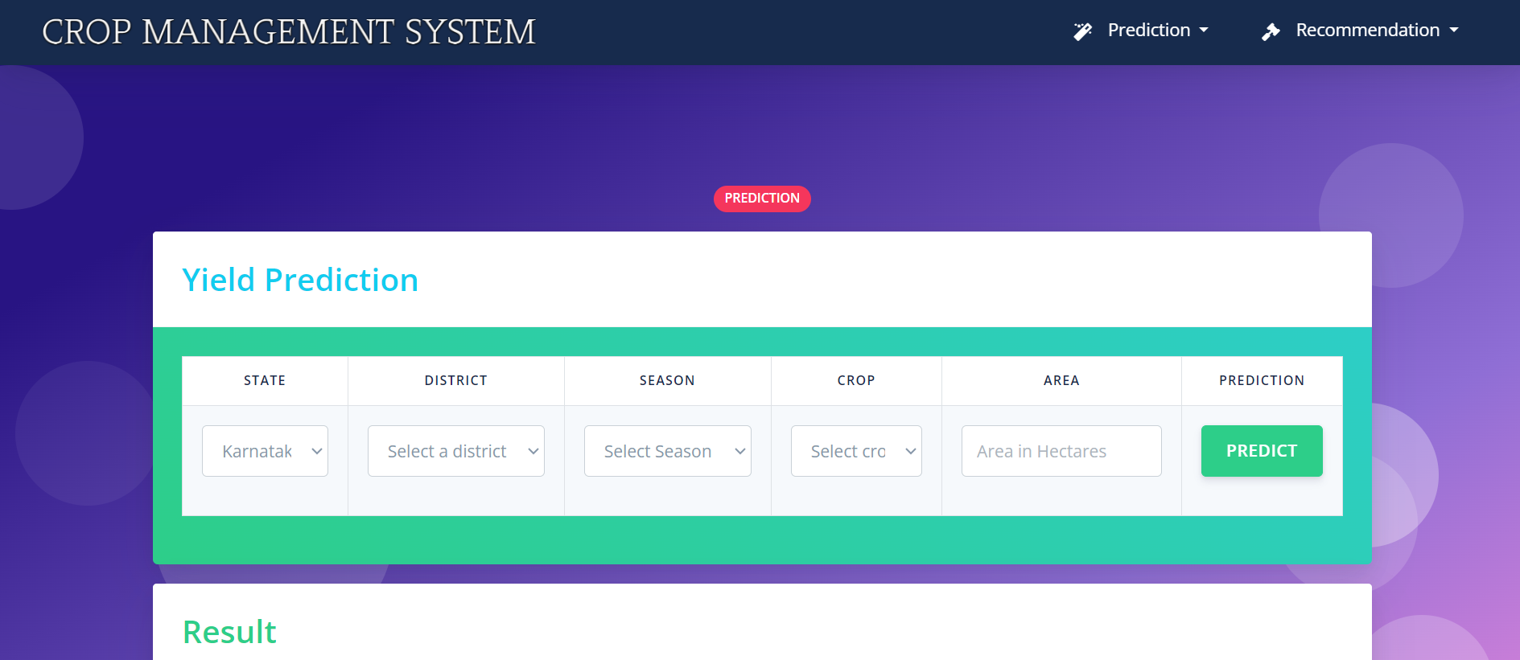

**Fig 5.4: Yield Prediction**

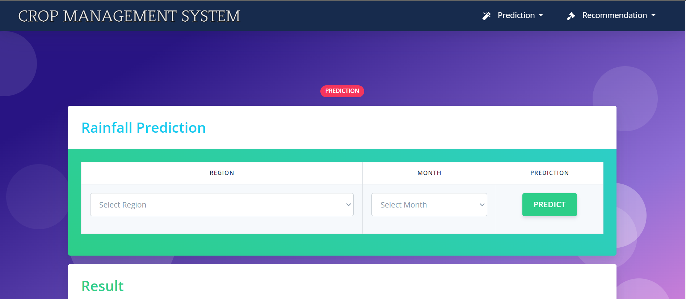

**Fig 5.5: Rainfall Prediction**

## RESULT

The Agriculture Recommendation System (ARS) demonstrates promising outcomes in optimizing crop management practices and enhancing agricultural productivity. Through rigorous testing and validation, the ARS showcases accurate and reliable performance across its various modules.In the Crop Prediction module, the ARS accurately forecasts the most suitable crops for given locations based on inputs such as State Name, District Name, and Season. This capability enables farmers to plan their planting strategies effectively, resulting in improved crop selection and yield outcomes.Similarly, the Crop Recommendation module provides personalized recommendations based on factors such as Nitrogen, Phosphorous, Potassium, Temperature, Humidity, pH, and Rainfall. Farmers benefit from tailored suggestions that consider specific environmental conditions, leading to optimized crop choices and enhanced productivity.Moreover, the Fertilizer Recommendation module offers customized fertilizer recommendations, considering inputs like Temperature, Humidity, Soil Moisture, Soil Type, Crop Type, and nutrient levels. This helps farmers optimize nutrient management practices, leading to improved crop health and yield outcomes.The Rainfall Prediction module accurately forecasts rainfall patterns for specified subdivisions and years, aiding farmers in irrigation planning and risk management. This capability enables proactive decision-making and resource allocation, mitigating the impact of unpredictable weather events.Furthermore, the Yield Prediction module provides farmers with insights into anticipated crop yields based on inputs such as State Name, District Name, Crop Year, Season, Crop, Area, and Production. This enables informed decision-making regarding production planning and market forecasting, contributing to improved profitability and sustainability.Overall, the results demonstrate the efficacy of the ARS in empowering farmers with actionable insights and recommendations, ultimately enhancing productivity, sustainability, and resilience in agriculture. Continued refinement and enhancement of the ARS based on user feedback and emerging agricultural trends further solidify its role as a valuable tool for agricultural decision-making.

## CHAPTER 6

**CONCLUSION AND FUTURE ENHANCEMENT**

## CONCLUSION

In conclusion, the Agriculture Recommendation System (ARS) represents a significant advancement in agricultural decision support technology, offering farmers and agricultural stakeholders a powerful toolkit for optimizing crop management practices. Through the integration of predictive analytics, machine learning algorithms, and domain expertise, the ARS provides accurate and tailored recommendations across various aspects of crop cultivation, including crop selection, fertilizer application, irrigation planning, and yield forecasting.The ARS enables farmers to make informed decisions based on real-time insights and data-driven recommendations, leading to improved productivity, sustainability, and resilience in agriculture. By leveraging historical data, environmental parameters, and advanced modeling techniques, the ARS empowers farmers to mitigate risks, optimize resource allocation, and adapt to changing agricultural conditions.Furthermore, the user-friendly interface and scalable infrastructure of the ARS ensure accessibility and usability for farmers of all backgrounds and locations.

## FUTURE ENHANCEMENT

Looking ahead, several potential enhancements could further elevate the capabilities and impact of the Agriculture Recommendation System (ARS). One avenue for improvement lies in the integration of advanced sensing technologies, such as drones and satellite imagery, to gather real-time data on crop health, soil moisture, and environmental conditions.

By incorporating these data sources, the ARS can provide farmers with even more precise and timely recommendations, enabling proactive decision-making and optimized resource management.Furthermore, the ARS could benefit from the incorporation of predictive analytics models that account for climate change projections and extreme weather events. By leveraging climate data and scenario analysis techniques, the system can help farmers anticipate and adapt to changing environmental conditions, reducing vulnerability to climate-related risks and enhancing long-term resilience.Additionally, the ARS could expand its scope to include socio-economic factors and market dynamics in its recommendations. By integrating market data, price forecasts, and supply chain information, the system can assist farmers in strategic decision-making regarding crop selection, pricing strategies, and market timing, ultimately enhancing profitability and market competitiveness.Moreover, advancements in artificial intelligence and machine learning algorithms offer opportunities to enhance the predictive capabilities and automation features of the ARS. By leveraging deep learning techniques and neural networks, the system can improve the accuracy and granularity of its recommendations, enabling more personalized and adaptive decision support for farmers.Lastly, the ARS could benefit from enhanced collaboration and integration with other agricultural technologies and platforms. By interoperating with farm management software, IoT devices, and agricultural marketplaces, the ARS can offer a more seamless and holistic solution for farmers, streamlining workflows and maximizing the value of agricultural data.

In summary, future enhancements to the Agriculture Recommendation System hold the potential to further revolutionize agricultural decision-making, enabling farmers to navigate complex challenges, capitalize on emerging opportunities, and drive sustainable and resilient agricultural practices. Through ongoing innovation and collaboration, the ARS can continue to evolve and adapt to meet the evolving needs of farmers and agricultural stakeholders in an ever-changing agricultural landscape.

## APPENDIX

**SOURCE CODE:**

import pandas as pd

import numpy as np

import json

import sys

# Get the input parameters as command line arguments

jsonn = sys.argv[1]

jsonp = sys.argv[2]

jsonk = sys.argv[3]

jsont = sys.argv[4]

jsonh = sys.argv[5]

jsonph = sys.argv[6]

jsonr = sys.argv[7]

# Parse the JSON strings into Python objects

n_params = json.loads(jsonn)

p_params = json.loads(jsonp)

k_params = json.loads(jsonk)

t_params = json.loads(jsont)

h_params = json.loads(jsonh)

ph_params = json.loads(jsonph)

r_params = json.loads(jsonr)

#Read the dataset

dataset = pd.read_csv('ML/crop_recommendation/Crop_recommendation.csv')

#Divide the dataset into features and labels

X = dataset.iloc[:, :-1].values

y = dataset.iloc[:, -1].values

#Split the dataset into training and test sets

from sklearn.model_selection import train_test_split

X_train, X_test, y_train, y_test = train_test_split(X, y, test_size = 0.2, random_state = 0)

#Train the model using the Random Forest Classifier algorithm

from sklearn.ensemble import RandomForestClassifier

classifier = RandomForestClassifier(n_estimators = 10, criterion = 'entropy', random_state = 0)

classifier.fit(X_train, y_train)

#Get the user inputs and store them in a numpy array

#user_input = np.array([[90,42,43,21,82,6.5,203]]) - ans is rice.

user_input = np.array([[n_params,p_params,k_params,t_params,h_params,ph_params,r_params]])

#Make predictions using the trained model

predictions = classifier.predict(user_input)

#Print the predicted crop

print(str(predictions[0]))

**Fertilizer recommendation**

import pandas as pd

import sys

from sklearn.preprocessing import LabelEncoder

from sklearn.tree import DecisionTreeClassifier

# Load the dataset

data = pd.read_csv("ML/fertilizer_recommendation/fertilizer_recommendation.csv")

# Label encoding for categorical features

le_soil = LabelEncoder()

data['Soil Type'] = le_soil.fit_transform(data['Soil Type'])

le_crop = LabelEncoder()

data['Crop Type'] = le_crop.fit_transform(data['Crop Type'])

# Splitting the data into input and output variables

X = data.iloc[:, :8]

y = data.iloc[:, -1]

# Training the Decision Tree Classifier model

dtc = DecisionTreeClassifier(random_state=0)

dtc.fit(X, y)

# Get the input parameters as command line arguments

jsonn = sys.argv[1]

jsonp = sys.argv[2]

jsonk = sys.argv[3]

jsont = sys.argv[4]

jsonh = sys.argv[5]

jsonsm = sys.argv[6]

jsonsoil = sys.argv[7]

jsoncrop = sys.argv[8]

soil_enc = le_soil.transform([jsonsoil])[0]

crop_enc = le_crop.transform([jsoncrop])[0]

# Get the user inputs and store them in a numpy array - Urea

#user_input = [[26,52,38,'Sandy','Maize',37,0,0]]

user_input = [[jsont,jsonh,jsonsm,soil_enc,crop_enc,jsonn,jsonk,jsonp]]

fertilizer_name = dtc.predict(user_input)

# Return the prediction as a string

print(str(fertilizer_name[0]))

**RainFall Predictions**

import pandas as pd

import sys

# Load the dataset into a dataframe

df = pd.read_csv('ML/rainfall_prediction/rainfall_in_india_1901-2015.csv')

# Define a function to predict rainfall for a given district and month

def predict_rainfall(state, month):

# Filter the dataframe to only include rows with the given district

state_data = df[df['SUBDIVISION'] == state]

# Calculate the average rainfall for the given month across all the years

avg_rainfall = state_data[month].mean()

# Return the predicted rainfall for the given month

return avg_rainfall

# Get the input parameters as command line arguments

Jregion = sys.argv[1]

Jmonth = sys.argv[2]

#predicted_rainfall = predict_rainfall('ANDAMAN & NICOBAR ISLANDS', 'JAN')

predicted_rainfall = predict_rainfall(Jregion, Jmonth)

print(predicted_rainfall)

## REFERENCES

1. **Rajak, Rohit Kumar, et al. “Crop Recommendation System to Maximize Crop Yield using Machine Learning Technique.” *International Research Journal of Engineering and Technology (IRJET)*, vol. 04, no. 12, 2017, pp. 951-952. *IRJET*,** [**https://www.irjet.net/archives/V4/i12/IRJET-V4I12179.pdf**](https://www.irjet.net/archives/V4/i12/IRJET-V4I12179.pdf)**.**
2. **Dighe, Deepti, et al. “Crop Recommendation System for Precision Agriculture.” *IRJET*, vol. 05, no. 11, 2018, pp. 476-480. *IRJET*,** [**https://www.irjet.net/archives/V5/i11/IRJET-V5I1190.pdf**](https://www.irjet.net/archives/V5/i11/IRJET-V5I1190.pdf)**.**
3. **Mokarrama, Miftahul Jannat, and Mohammad Shamsul Arefin. “RSF: A Recommendation System for Farmers.” *Region 10 Humanitarian Technology Conference*, vol. 2, no. 17, 2017,**
4. **https://www.researchgate.net/publication/323203384_RSF_A_recommendation_system_for_far mers.**
5. **Gandge, Yogesh, and Sandhya. “A study on various data mining techniques for crop yield prediction.” *IEEE Xplore*, 2017. *IEEE Xplore*,** [**https://ieeexplore.ieee.org/document/8284541**](https://ieeexplore.ieee.org/document/8284541)**.**
6. ***Mishra, Shruti, et al. Use of data mining in crop yield prediction. 2018. ResearchGate,***
7. **https://www.researchgate.net/publication/326073480_Use_of_data_mining_in_crop_yield_predi ction.**
8. **[Wu, Xiaoping, et al. *A Large-Scale Benchmark Dataset for Insect Pest Recognition*. 2019. *IEEE Xplore*,**
9. **https://openaccess.thecvf.com/content_CVPR_2019/papers/Wu_IP102_A_Large-Scale_Benchm ark_Dataset_for_Insect_Pest_Recognition_CVPR_2019_paper.pdf.**
10. **TÜRKOĞLU, Muammer, and Davut HANBAY. *Plant disease and pest detection using deep learning-based features*. 2018. *Turkish Journal of Electrical Engineering & Computer Sciences*,** [**https://journals.tubitak.gov.tr/elektrik/issues/elk-19-27-3/elk-27-3-6-1809-181.pdf**](https://journals.tubitak.gov.tr/elektrik/issues/elk-19-27-3/elk-27-3-6-1809-181.pdf)**.**
11. **Selvaraj, Michael Gomez, et al. *AI-powered banana diseases and pest detection*. 2019. *Plant Methods*,**